Lull
Product & Business Analysis
This document asks the hard questions about Lull: who it is for, how we would know it is working, what to build next, how it could pay for itself, and what could go wrong.
Lull is a text-based movement companion: you tell it what today needs, it suggests a short session, and it stays with you through it. It runs locally, uses no paid services by default, and is honest about what it can and cannot do.

How to read this. Anything about the market, prices or people’s behaviour that I have not measured is marked Assumption. Numbers from the Insights screen come from a synthetic sample of made-up people that ships with the prototype so the screen can be demonstrated. They show how the analysis would work. They are not evidence that Lull works.
Adapted from a starter harness provided for a take-home exercise.

Contents
1. The problem and the opportunity
The problem in one paragraph
What Lull does about it
Why this might be worth doing
What it is not
2. Who it is for
Jobs to be done
3. Where it sits next to the alternatives
Positioning statement
4. The journey, step by step
5. How we would know it is working
The one number to watch
Guardrails
What is logged, exactly
Reading the synthetic sample
6. From user need to code to test
7. What to build next
Roadmap
8. How it could pay for itself
What a session costs to run
9. What could go wrong
10. How to find out if we are right
The hypotheses to test first
Usability test script (30 minutes, 5 people)
Interview guide (problem interviews, 8–10 people)
When to stop, change direction, or go on
Appendix: what was added to the prototype for this analysis

1. The problem and the opportunity

The problem in one paragraph
A lot of people sit for most of the day and know they should move more. The trouble is rarely knowledge. It is the moment itself: you have ten minutes, you feel stiff or flat, and choosing what to do takes more energy than you have. Fitness apps assume you already want a workout. Meditation apps assume you want to sit still. Reminder apps tell you to stand up and then leave you there. Nobody asks “what does today need?” and then helps you do one small, sensible thing.

What Lull does about it
- One question in, one session out. You type a need in your own words (“I’ve been sitting all day”, “I have ten minutes”) and get a short, specific suggestion.
- It stays with you. Each movement has a timer, a cue and a clear next step. You can say “too easy” or “my knee hurts” at any point and the session changes, or stops safely.
- It does not overclaim. It cannot see you, does not count reps, does not promise weight loss and says so. Timers measure time on the page, not exercise.
- It is private by default. No account. Memory and the activity log stay in the browser and can be turned off or cleared.

Why this might be worth doing
Assumption. Desk-based work has grown with hybrid working, and employers increasingly pay for wellbeing benefits. I have not sized this market. Before any investment I would want real figures for (a) how many people in a target city or company sit for six-plus hours a day, (b) what share already pay for a fitness or wellbeing app, and (c) what employers in India and the UK currently spend per employee on wellbeing.
The more useful question at this stage is not “how big is the market?” but “does the smallest version of this help anyone enough that they come back?”. That is what the metrics and the validation plan in this document are built to answer.

What it is not
- Not a fitness tracker, a coach that sees you, or a medical tool.
- Not a streak machine. There are no badges, guilt messages or “you missed a day” notifications. That is a deliberate choice, and it shapes the metrics too (see section 5).

2. Who it is for
These are working personas built from the problem, not from research. Each one should be tested in the interviews described in section 10, and dropped or rewritten if it does not hold up.
Assumption. These people exist in meaningful numbers and recognise themselves in these descriptions. Not yet validated.
 | Priya, 29 | Arjun, 41 | Meera, 56
Situation | Software developer, hybrid. Long screen days, eats lunch at her desk. | Team lead, back-to-back calls. Used to play cricket, now stiff and out of the habit. | Teacher, on her feet but tense by evening. Mild knee trouble. Not into “workouts”.
What she / he says | “I know I should stretch. I just never decide what to do.” | “I don’t have 45 minutes. I have 10, maybe.” | “I want something gentle that won’t hurt my knee.”
What gets in the way | Decision fatigue. Too many choices in fitness apps. | Time, and apps that assume a full workout. | Fear of doing it wrong or hurting herself.
What a good outcome looks like | Takes a 3-minute mobility break most workdays without thinking about it. | Gets moving for 10 minutes a few times a week and feels less stiff. | Has a calm routine she trusts, and knows when to stop.
What Lull must get right | Speed from opening to first movement. | Honest short sessions; “too easy” should actually make it harder. | Safety handling, gentle language, no pressure.

Jobs to be done
A job is the progress someone is trying to make, written in their words. These are the jobs Lull is designed around:
When I… | I want to… | So that…
have been sitting for hours and feel stiff | do something short that loosens me up | I can get back to work without aching
have a small gap and low energy | be told exactly what to do, without choosing | I actually move instead of scrolling
start something and it feels too easy or too much | change it there and then | the session fits how I feel today
feel pain or something isn’t right | be told clearly to stop | I don’t make an injury worse
finish | have a quiet moment of closure | it feels like a break, not a chore

3. Where it sits next to the alternatives
People with this problem already have options. The real competitor is often “nothing” or a YouTube video. The table describes categories, with well-known examples, as I understand them in general terms.
Assumption. These are broad characterisations, not a feature audit. Products change often. Before using this in a pitch, check each product’s current features and pricing.
Option | What it is good at | Where it leaves a gap for this person | Lull’s difference
Full fitness apps (e.g. Nike Training Club, Peloton app) | Large libraries, structured programmes, high production value. | Assume you want a workout. Lots of choice up front. | Starts from how you feel, picks one thing, 2–5 minutes.
Meditation apps (e.g. Headspace, Calm) | Calm tone, habit design, audio. | Mostly about sitting still. Movement content is secondary. | Movement first, with the same calm tone.
Break reminders (e.g. stand reminders on watches, desktop break apps) | Prompting at the right time. | They nudge but don’t guide. “Stand up” then nothing. | Guidance after the nudge (reminders are on the roadmap, not built).
YouTube “desk stretch” videos | Free, endless choice. | Searching takes time; no adapting; ads. | No searching; adapts when you say “too easy”.
Doing nothing | Zero effort. | Stiffness and low energy carry on. | Makes the first step small enough to take.

Positioning statement
For people who sit most of the day and struggle to decide what to do with a short break, Lull is a movement companion that turns “how I feel right now” into a few minutes of guided movement. Unlike fitness apps, it starts from your need rather than a catalogue, and it is honest about what it can’t see or measure.

4. The journey, step by step
This is the current journey in the prototype, with what the person is likely thinking and where they might drop off. Each drop-off point maps to a step in the funnel on the Insights screen.
Stage | What happens | What they may be thinking | Risk of leaving | What the prototype does about it
Arrive | Home screen: one “Start” button, three quick picks with real durations, a box to type a need. | “Is this going to take long?” | Medium | Durations are shown up front and match the actual timers.
Say what you need | Type a need, or answer two or three short questions. | “Do I have to fill in a form?” | High | Questions are one at a time; typing anything works; quick picks skip this entirely.
See the suggestion | A specific session with a reason (“you mentioned sitting, so…”). | “Is this right for me?” | Medium | Accept, adjust, or choose something else. Nothing is forced.
First movement | Timer, cue, optional 3-2-1 countdown. | “Am I doing it right?” | Medium | Plain cues; Lull says it can’t see you.
During | Movements in sequence. Can type “too easy”, “stop”, “my knee hurts”. | “This is too easy / too much.” | Medium | Offers a change in place; safety stops the session clearly.
Finish | Quiet closing screen, a short honest record, an optional one-tap “How did that feel?”. | “That was nice / pointless.” | Low | No streaks or guilt; the question is optional and one tap.
Come back | If “remember me” is on, a greeting and “Same as last time”. | “Will I bother tomorrow?” | High | Lowest-effort return path. No push notifications (not built).

5. How we would know it is working

The one number to watch
North star: weekly sessions that reach the end, per active person. It is simple, it only goes up when people get real value (they finished something), and it does not reward the wrong things. Time in app would reward slowness. Daily opens would push towards nagging. Streaks would punish people for missing a day, which goes against the whole idea.
Underneath it sit four things we can change. If the north star moves, one of these will tell us why:
Driver | Question it answers | How it is measured in the prototype
Getting started | Do people get from opening the app to moving? | Funnel: opened → chose a session → started the first movement. Median seconds from session shown to first timer.
Finishing | Once they start, do they reach the end? | “Reach the end”: visits where a session was chosen and Finish was pressed on the closing screen.
Fit | Did the session suit them? | Share who asked for a change, share who accepted the offer, and the one-tap feeling answer.
Coming back | Does it become a habit without nagging? | People who finished once and came back on a different day.

Guardrails
These should never get worse while chasing the north star:
- Safety stops end safely, every time. A safety report must never lead into a workout. This is tested automatically (see section 6).
- “Not for me” answers. If these rise, we are pushing the wrong sessions.
- Unmatched requests. If more people type things Lull does not understand, coverage is slipping.

What is logged, exactly
Everything below is stored only in the browser, can be switched off in Settings, cleared, or exported as JSON. Free text is never stored, except for requests Lull did not understand, because those are the backlog.
Event | When it is recorded | Extra detail kept
visit | The app is opened | none
exposure | Each experiment variant shown on this visit | experiment id, variant A or B
entry | The first message of a visit | route: quick pick, typed need, full welcome, or same as last time
need | Lull recognised a typed need | the kinds it heard (e.g. “a lot of sitting”)
unmatched | Lull could not understand a request | the text (first 120 characters), before or during a session
session_loaded | A session plan appears | session title
timer_started | A movement timer is started for the first time | movement label
timer_done | A timer runs out, or is marked finished early | early: yes/no
offer / adjusted | Lull offers a change; the person accepts | what was asked for (harder, easier, switch, stop)
safety | Pain, injury or dizziness is reported | before or during; pain or urgent
session_finished | Finish pressed, the person stopped, or safety ended it | reason
feeling | The optional end question is answered | lighter, about the same, not for me
returned | First visit on a new day after finishing on an earlier day | none
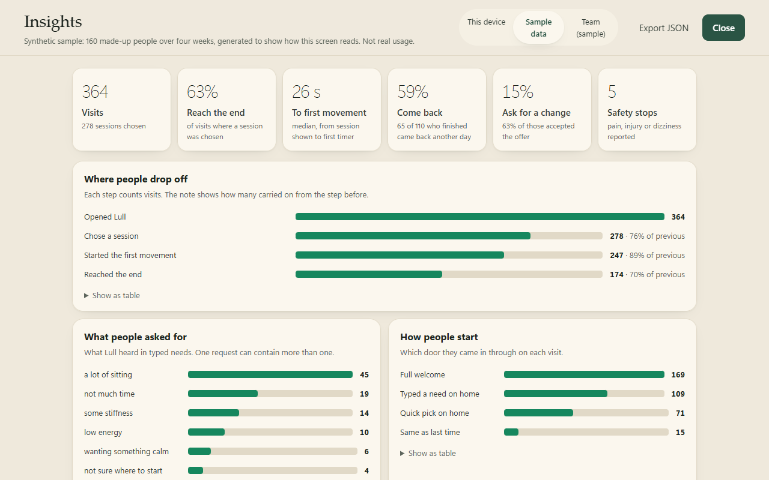
The Insights screen, showing the synthetic sample. The sample is labelled at the top and cannot be confused with real data.

Reading the synthetic sample
The sample is 160 made-up people over four weeks, built with fixed rates so it is the same every time. It produces 364 visits, 278 sessions chosen, 247 first movements and 174 sessions reaching the end. The biggest drop is between opening the app and choosing a session (76% carry on). Of the three steps, that is the first one I would work on if real data looked like this.
Reminder. These numbers were made up to show how the screen reads. They tell us nothing about real people.

6. From user need to code to test
Each row links a user story to where it lives in the code and to the automated test that proves it. Test names are quoted exactly as they appear in the test suite, so anyone can search for them. The suite has 85 unit tests and 36 browser tests.
User story | Where it lives | Test that proves it
As someone short on time, I can see how long a quick session takes before I start. | src/web/app.ts (home quick picks); src/server/lull.ts (session program) | “home quick picks state the real timer totals”; “declared durations always equal the sum of the session timers”
As someone who doesn’t know what they need, I can type it in my own words. | src/server/lull.ts (interpretNeed); src/server/mock.ts | “free-text needs map deterministically onto existing paths, ask when unclear and stay honest”; “home: a typed need opens the decision, a question, or the safety screen, and continues from there”
As someone in pain, I am told to stop rather than given a workout. | src/server/lull.ts (careStatements, safety) | “pain, rehab and urgent symptoms replace the choices instead of routing into a workout”; “safety holds the session: no offers, no progression, and an explicit decision to leave”
As someone mid-session, I can say “too easy” and the session changes without starting over. | src/server/lull.ts (offers); src/web/app.ts (renderWorkout) | “an in-session change is offered, confirmed, and applied in place without restarting the journey”
As anyone, I am never told I exercised when I only ran a timer. | src/shared/openui/recap.ts | “recap wording separates full timers, simulated finishes, open and unstarted timers”
As a returning person, I can opt in to being remembered, and be forgotten. | src/web/prefs.ts | “remember me is opt-in, greets you on return, offers the last session, and forgets on request”
As a keyboard or screen-reader user, I can run a session without a mouse. | src/web/app.ts (keyboard handler, announcer) | “keyboard: Space starts and pauses the timer, arrows move; focus mode quiets everything else”
As the product owner, I can see where people drop off without sending data anywhere. | src/web/analytics.ts; src/shared/insights.ts; src/web/insights-view.ts | “insight definitions: funnel by visit, finish rate, first movement, return and change rates”; “a real session shows up in Insights: funnel, need, route, feeling and the unmatched request”
As a privacy-minded person, I can turn tracking off and nothing is recorded. | src/web/analytics.ts (logging switch) | “turning the activity log off removes the closing question and records nothing”
As the product owner, I don’t declare a winner from too little data. | src/shared/insights.ts (compare) | “experiment comparison: honest verdicts with a 95% range”
As a developer, I can force an experiment variant to demo or debug it. | src/web/analytics.ts (setOverride); Developer tab | “experiment override: variant B of the home test shows the guided start only”
As a cautious team, the app never calls a paid model unless someone opts in. | src/server/config.ts; src/server/provider.ts; src/server/cli.ts | “runtime starts mock; Codex blocked; selecting never calls model endpoint”; “CLI requires explicit local opt-in, profile acknowledgement and per-request consent”
Honest gap. Four unit tests fail on Windows only (three check the Claude command-line adapter, one checks symlink handling). Three cover the optional Claude command-line adapter, which only supports macOS and Linux. One creates a symlink, which Windows only allows in Developer Mode. Both features are off by default. I have only run the suite on Windows, so these are listed here rather than hidden.

7. What to build next
Ideas are scored with RICE: Reach (people affected per month, out of an assumed 1,000 active), Impact (3 = big, 2 = medium, 1 = small, 0.5 = tiny), Confidence (how sure we are, %), Effort (person-weeks). Score = Reach × Impact × Confidence ÷ Effort.
Assumption. All Reach and Effort figures are estimates for a small team and an imagined base of 1,000 monthly active people. The point is the ranking and the reasoning, not the exact scores.
Idea | Why | R | I | C | E | Score
Wrist, hand and eye breaks for screen workers | Top unmatched request in the sample (“my wrists ache from typing”). | 400 | 2 | 70% | 1 | 560
Gentle reminders, chosen by the person | Coming back is the riskiest step in the journey map, and there is no way to prompt a return today. | 600 | 2 | 50% | 2 | 300
Cooldown after a run or walk | Unmatched request; a small new path using existing pieces. | 150 | 1 | 70% | 0.5 | 210
Lying-down and bed-friendly sessions | Unmatched request; helps people with low energy or limited mobility. | 120 | 2 | 60% | 1 | 144
Content reviewed by a physiotherapist | Trust, and required before any health or workplace claims. | 1000 | 1 | 80% | 6 | 133
Hindi and other languages | Opens the Indian market beyond English speakers. | 300 | 2 | 50% | 6 | 50
Accounts and sync across devices | Needed for teams and multiple devices; adds privacy work. | 250 | 1 | 50% | 5 | 25
Voice guidance | Hands-free sessions. Big change, and not something to claim until built. | 500 | 2 | 30% | 10 | 30

Roadmap
Now (next 4–6 weeks) | Next (the quarter after) | Later (once the basics are proven)
Run 8–10 interviews and 5 usability tests (section 10).  Add wrist, hand and eye breaks.  Add a cooldown path.  Decide the home-screen experiment. | Opt-in reminders the person schedules.  Lying-down sessions.  Physiotherapist review of every movement and cue.  A small paid pilot with one employer. | Accounts and sync.  Hindi.  Voice guidance.  A live-model mode for open conversation, if testing shows people want it.
The order follows a simple rule: first make sure the core loop helps people (interviews, gaps in coverage), then make it easier to return (reminders), then widen who it serves (languages, voice).

8. How it could pay for itself
There are two realistic routes. They are not exclusive, but each one changes what gets built first.
 | A. Individuals (freemium) | B. Employers (workplace wellbeing)
Who pays | The person. | The employer, per employee.
What is free / paid | Free: core sessions and safety. Paid: more paths, reminders, sync, voice later. | Everything included. Paid on a per-seat or per-active-person basis.
Pricing hypothesis | Around ₹149–199 / month in India; around £3–4 / month in the UK. Assumption, to be tested. | Around ₹60–120 per employee per month; pilot price for one team. Assumption, to be tested.
What it needs | App store presence, strong return rate, low support cost. | Sales effort, admin reporting, privacy terms, security review.
Biggest risk | People don’t pay for small things they can get free on YouTube. | Long sales cycles; employers want reporting that could feel like surveillance.
What has to be true | Coming back without nagging works. Paid features are clearly worth it. | Aggregated, anonymous reporting is enough for buyers. Employees trust it.
My recommendation: start with a small employer pilot (route B). One team gives a defined group to interview, a reason to get physiotherapist review done early, and a clearer signal on whether people come back. The privacy design already here (nothing leaves the device) is a selling point to employees, and any employer reporting would have to be aggregated and opt-in.

What a session costs to run
Today, sessions cost nothing in model fees: the default Mock mode is deterministic and runs on the device’s server. A live model would be optional. Its cost per session is roughly:
Formula. cost per session = turns × (input tokens per turn × input price + output tokens per turn × output price)
The prototype already limits the input: it sends at most the last 30 turns and compacts long screen documents, so input per turn stays bounded. To make this real, plug in the current per-token price of the chosen model and the measured turns per session from Insights.
Assumption. Illustration only: 8 turns × (6,000 input tokens × $1 per million + 600 output tokens × $5 per million) ≈ $0.07 per session. These prices are placeholders, not quotes. At 20 sessions per person per month that would be about $1.40, which is why live mode would sit behind a paid tier or stay optional, while Mock covers everyday use.

9. What could go wrong
Likelihood and impact are rated Low, Medium or High. “In place now” means already built and tested in the prototype; everything else is a plan.
Risk | L | I | In place now | Still to do
Health claims. Implying it treats pain, causes weight loss or replaces a professional. | M | H | Wording never promises outcomes; weight goals framed honestly; recap never claims exercise was done. | Legal review of all copy before launch; physiotherapist sign-off.
Physical safety. Someone keeps going through pain. | M | H | Pain, injury and dizziness stop the session and replace the choices; urgent symptoms point to help; tested automatically. A public safety page lists example phrases, and a test checks each one really triggers the response. Writing that test found three common phrases that were being missed (“fainting”, “dizziness”, “feeling sick”), which are now caught. | Clinician review of the trigger words and safety text; add pregnancy and condition guidance.
Privacy. Personal or health-related data handled carelessly. | L | H | No account; memory is opt-in; activity log stays in the browser, can be turned off, cleared and exported. | Before any server-side data: a privacy notice, consent records, and data processing terms under the UK/EU GDPR and India’s Digital Personal Data Protection Act 2023. Treat any health detail as sensitive.
Workplace misuse. Employer reporting used to watch individuals. | M | H | Nothing leaves the device today. The team view (on sample data) shows totals only, hides teams under 10 people, and hides one more team when a lone small team could be worked out by subtraction. Tested automatically. | Combine real data across devices only for people who opt in; let employees see exactly what is shared.
Accessibility. People using screen readers, keyboards or low vision are shut out. | L | M | WCAG AA contrast in both themes; keyboard control; screen-reader announcements; reduced motion respected. | Testing with disabled users; a formal audit.
AI reliability. A live model says something unsafe or invents things. | M | H | Mock is the default; model output is validated against a fixed component catalogue; invalid screens are rejected; live mode needs explicit consent. | Keep safety handling in trusted code, not the model; red-team testing before enabling live mode for anyone.
Nobody comes back. It helps once, then is forgotten. | H | H | Remember-me and “Same as last time” lower the effort to return. | Test opt-in reminders; measure return rate in a real pilot.

10. How to find out if we are right

The hypotheses to test first
# | We believe… | We will know we are right if… | How
H1 | Starting from “what does today need?” is easier than browsing a catalogue. | Most people in testing reach the first movement within 60 seconds without help. | Usability test; Insights “to first movement”.
H2 | Quick picks on the home screen get more people moving. | Variant A beats B on visits that start a timer, with a range that excludes zero. | The built-in home-screen experiment.
H3 | A 3-2-1 countdown makes starting calmer without causing people to give up. | Finish rate with the countdown is no worse than without it. | The built-in countdown experiment.
H4 | People will come back without streaks or nagging. | At least 1 in 3 who finish once come back within a week in a pilot. | Insights “come back”; interviews.
H5 | Employers will pay for this. | At least 2 of 10 HR or wellbeing leads agree to a paid pilot. | Sales conversations.
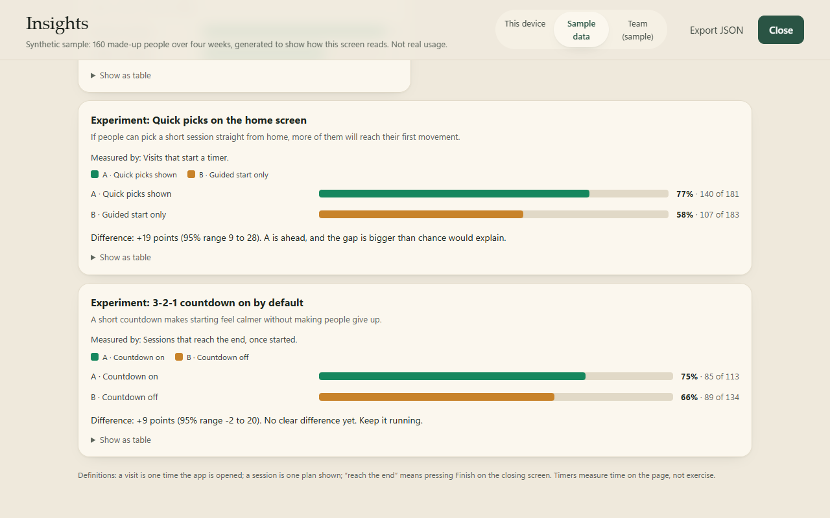
Experiment readouts on the synthetic sample. Each one states its hypothesis, the measure, the size of the gap with a 95% range, and a plain verdict. It refuses to name a winner below 30 visits per variant.

Usability test script (30 minutes, 5 people)
Run it on a laptop with the prototype in Mock mode. Ask people to think aloud. Don’t help unless they are stuck for more than a minute.
- Warm-up (3 min). “Tell me about the last time you tried to fit some movement into a workday. What happened?”
- First look (2 min). Show the home screen. “What do you think this is? What would you do first?”
- Task 1 (5 min). “You’ve been sitting all morning and have five minutes. Use this to do something about it.” Watch: do they type, use a quick pick, or start the welcome?
- Task 2 (5 min). Halfway through: “Imagine this feels too easy. What would you do?”
- Task 3 (3 min). “Now imagine your lower back starts to hurt.” Watch: is the safety response clear and calming?
- Ending (3 min). “How did the end of that feel? Was anything missing?”
- Wrap-up (9 min). “Would you use this again? When? What would stop you? What would you pay, if anything?”
Record: time to first movement, where they hesitated, words they used for their needs (these feed the need parser), and anything they expected that wasn’t there.

Interview guide (problem interviews, 8–10 people)
These come before testing the product. The aim is to learn about their days, not to sell Lull.
- Walk me through a typical workday. When do you notice your body most?
- Tell me about the last time you tried to move during the day. What did you do? What got in the way?
- What have you tried before (apps, videos, routines)? What made you stop?
- If something told you to stretch right now, what would make you actually do it?
- Have you ever felt pain while exercising? What did you do?
- How would you feel if your employer offered something like this? What would you not want them to see?
Avoid: leading questions (“Would you like an app that…?”), asking about the future instead of the past, and pitching. Write down exact phrases, because the words people use for their needs are the best input for the need parser.

When to stop, change direction, or go on
- Go on if H1 and H4 hold and at least one employer agrees to a pilot.
- Change direction if people like the sessions but don’t come back. That points to reminders or a different setting, such as part of an existing workplace tool.
- Stop if people consistently prefer a free video and nothing in the interviews explains why Lull would be different for them.

Appendix: what was added to the prototype for this analysis
- A private activity log (src/web/analytics.ts). It records the events in section 5, only in this browser. It can be switched off or cleared in Settings → Insights.
- The Insights screen (src/web/insights-view.ts, src/shared/insights.ts). It shows headline numbers, the drop-off funnel, needs, entry routes, the end-of-session feeling, unmatched requests, safety stops and experiment readouts. Every chart has a table view and works in light and evening themes. It can switch between this device’s data and the labelled synthetic sample, and exports JSON.
- The one-tap feeling question at the end of a session: Lighter / About the same / Not for me / Skip. It only appears when the activity log is on.
- Experiments in the Developer tab. Two A/B tests (quick picks on home; countdown on by default), each with its hypothesis written next to it and a switch to force a variant for demos. A person’s own countdown setting always wins over the experiment.
- A team view (src/shared/team.ts). This is what an employer would see in a pilot, shown on a made-up 64-person company. It shows people active each week, how many are still using it, totals by team and when breaks happen. It never shows names, individual sessions, typed text or who reported pain. Teams under 10 people are hidden, and one more is hidden when a single small team could otherwise be worked out by subtraction.
- A landing page for HR and wellbeing leads at /teams. It covers how it works, safety, privacy, the team view and what a pilot looks like, and has a pilot request form. The form only checks the fields and then says that nothing was sent.
- A safety and limits page at /safety. It covers how pain and symptoms are handled (with the honest limit that phrase matching can miss unusual wording), what Lull never claims, a review table showing physiotherapist review as pending for every session, and an accessibility statement that lists what hasn’t been done.
- A one-page pilot proposal (docs/Lull - Pilot Proposal.pdf). It covers six weeks, one team, four targets agreed up front, privacy in plain English, what we need from the employer and an indicative price. It says the pilot won’t start until the physiotherapist review is done.
- A reminder concept (docs/concepts/chat-nudge.html). It mocks up opt-in reminders inside team chat, labelled as not built. Reminders scored second on the backlog in section 7.
- Tests. Three unit tests pin down the metric definitions and the experiment verdicts. Four browser tests check that a real session appears in Insights, the sample is labelled, switching the log off records nothing, and the experiment override works. Three more unit tests check the team view’s privacy rules, and three browser tests check the landing page, the pilot form and the team view.
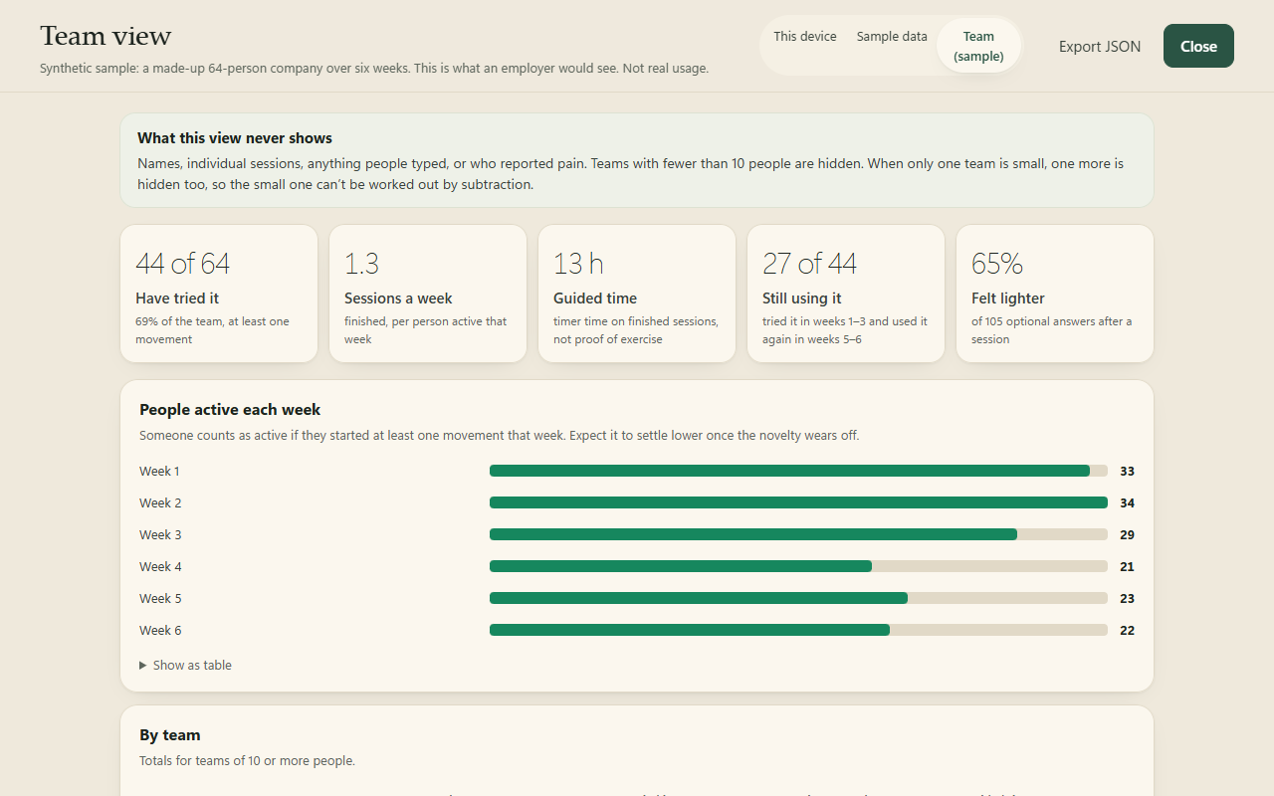
The team view on the made-up 64-person company. Totals only, with the privacy rules stated at the top.

